Flood fill:

The algorithm by which the mouse navigates through the maze to the center.

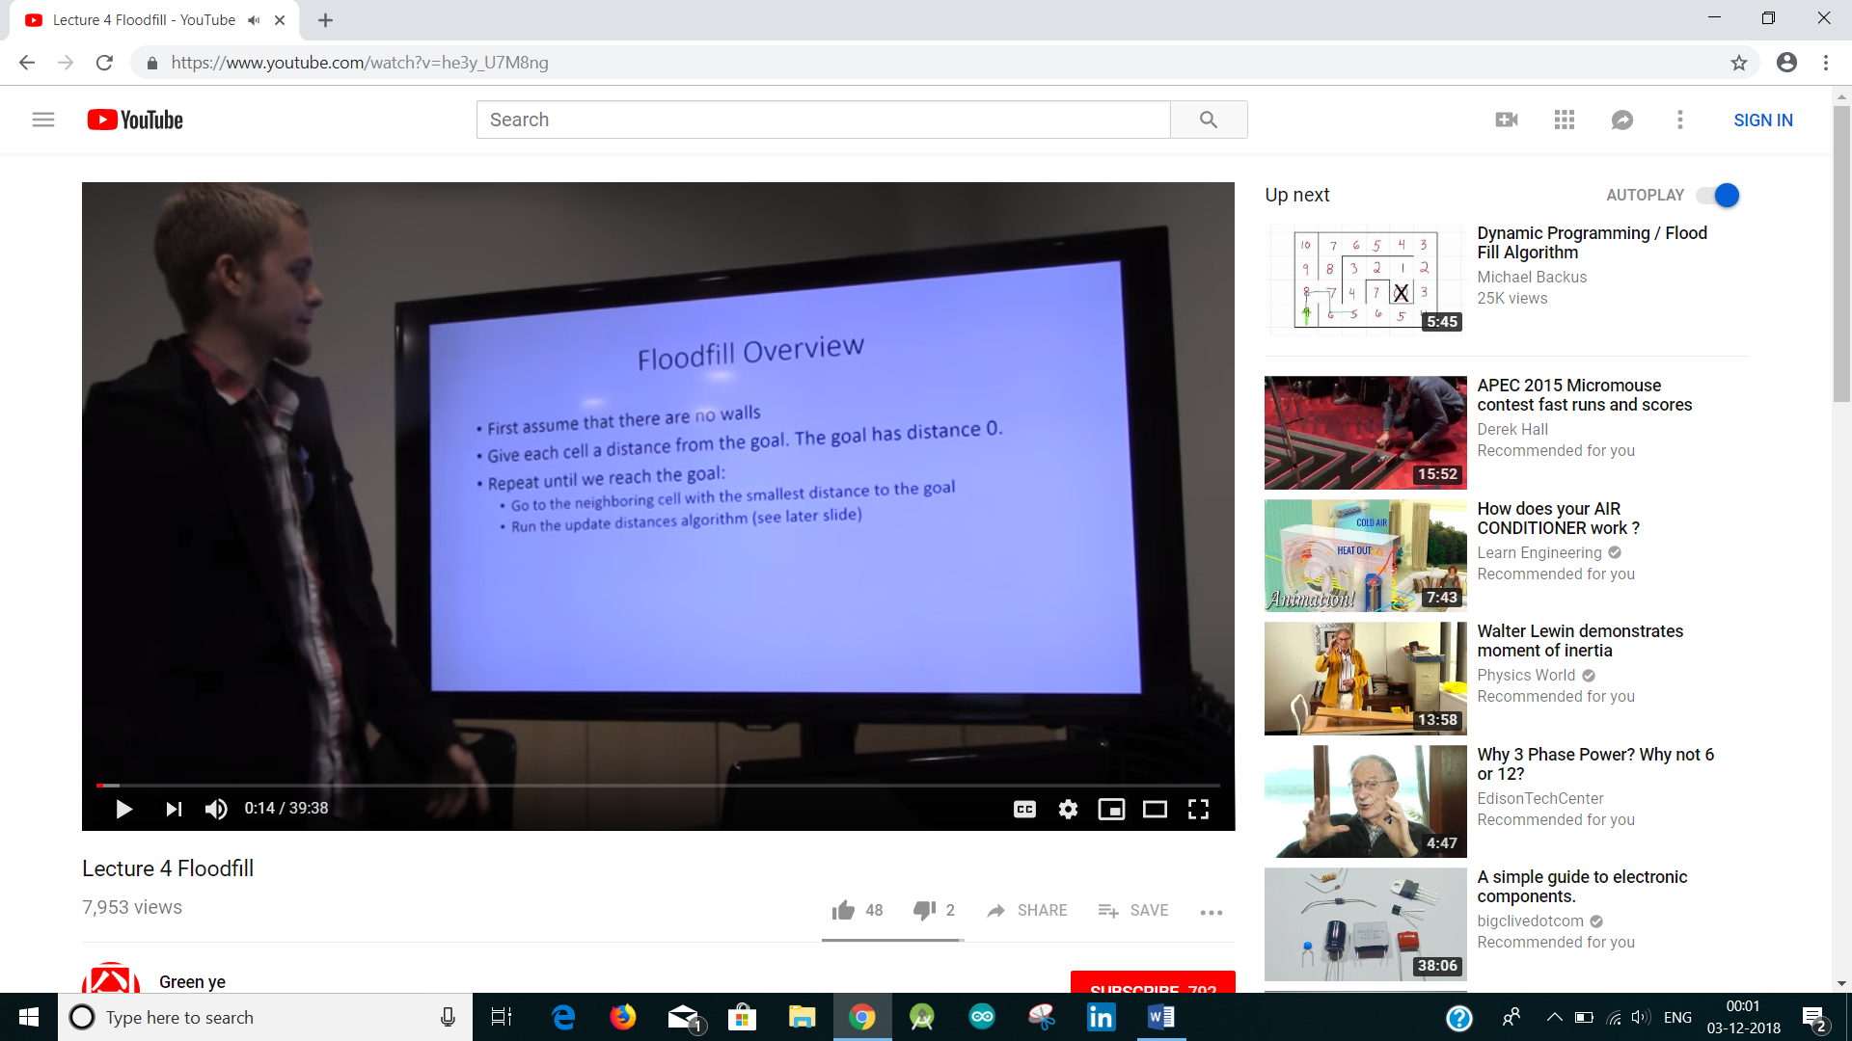

So each cell has a number which is equal to the distance of each cell from the goal. The distance of center is zero. From the start go to the adjacent cell with smallest number to the goal ie, nearer to the goal. Remember to update the distances each time you discover a wall.

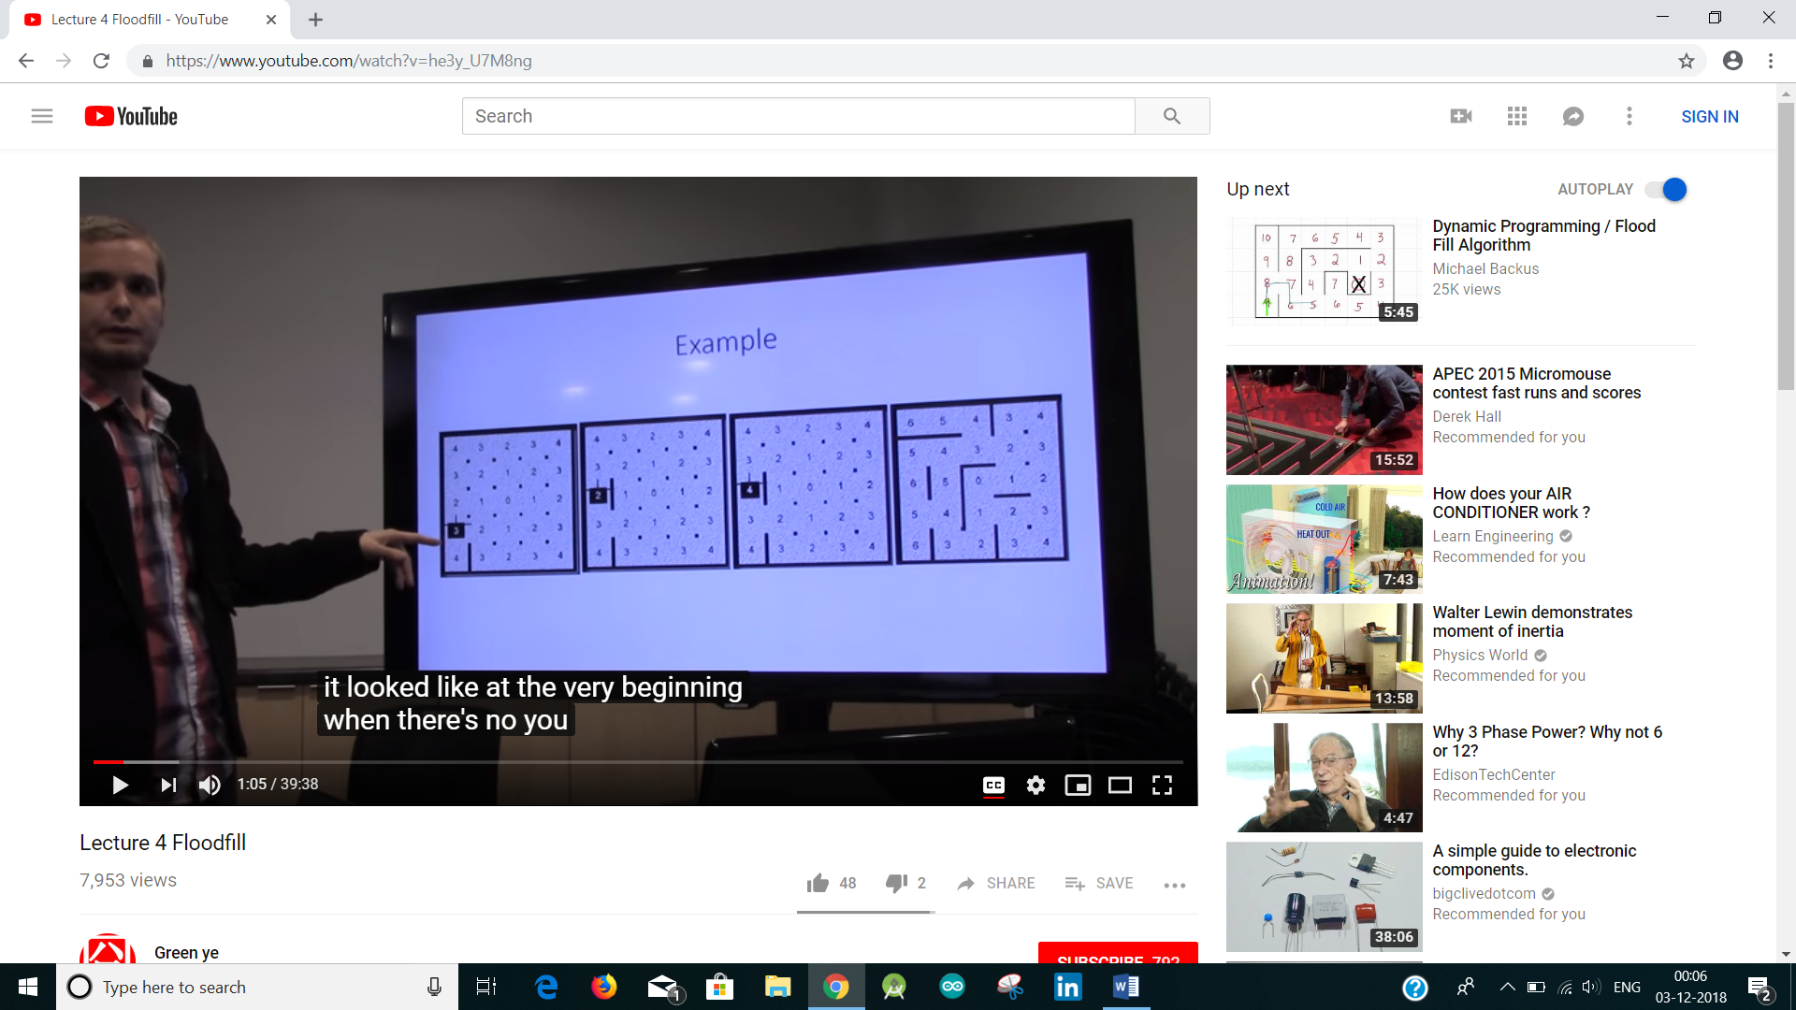

So now as the mouse moves from 3 to 2 it discovers a wall, and it can’t move to the center by just 2 steps due to wall. Hence it updates the number in the square as 4.

How to represent it in a code?

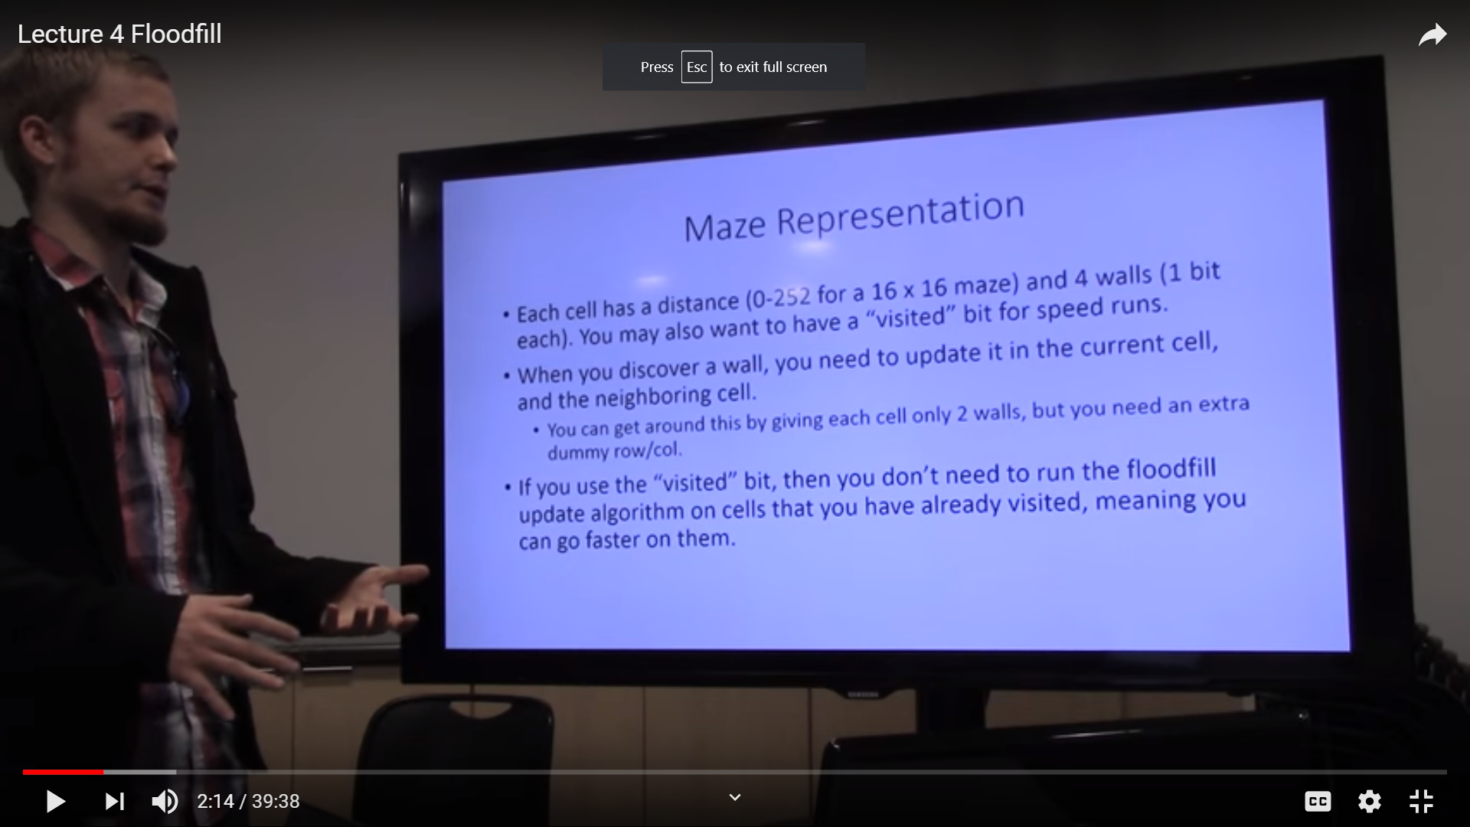

Q. Why 0-252?

You have an array of 16 x 16 to store the distance from the center. Also bits to store individually if a wall is there or not, ie 1 for wall and 0 for no wall. And one more visited bit in there for each cell.

Q. while going wall on right, while coming wall on left? How does it know?

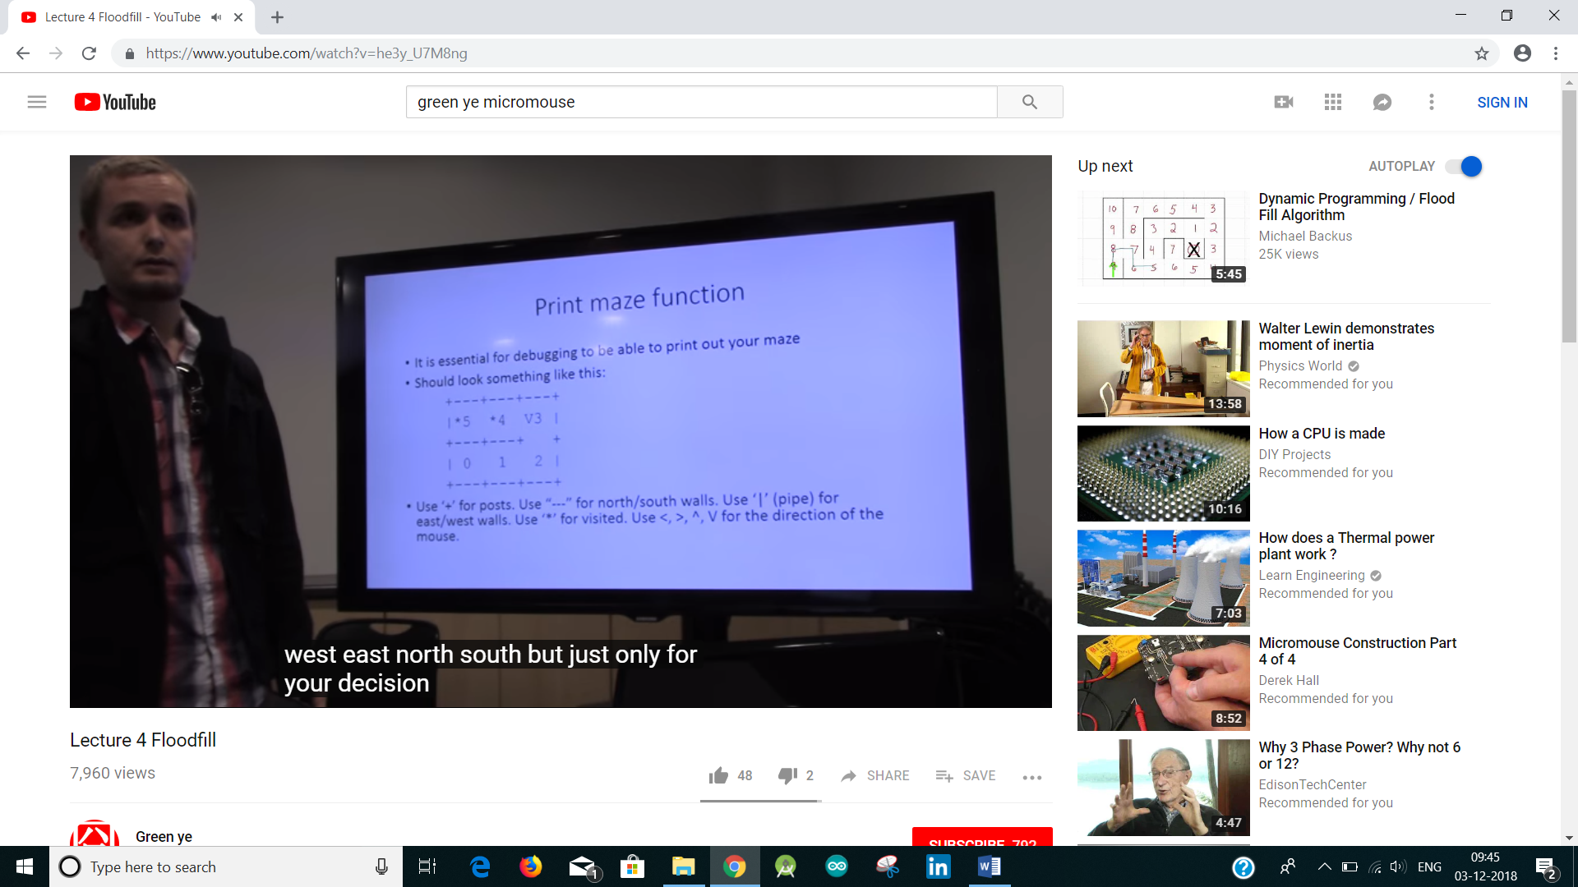

Printing Maze helps in debugging.

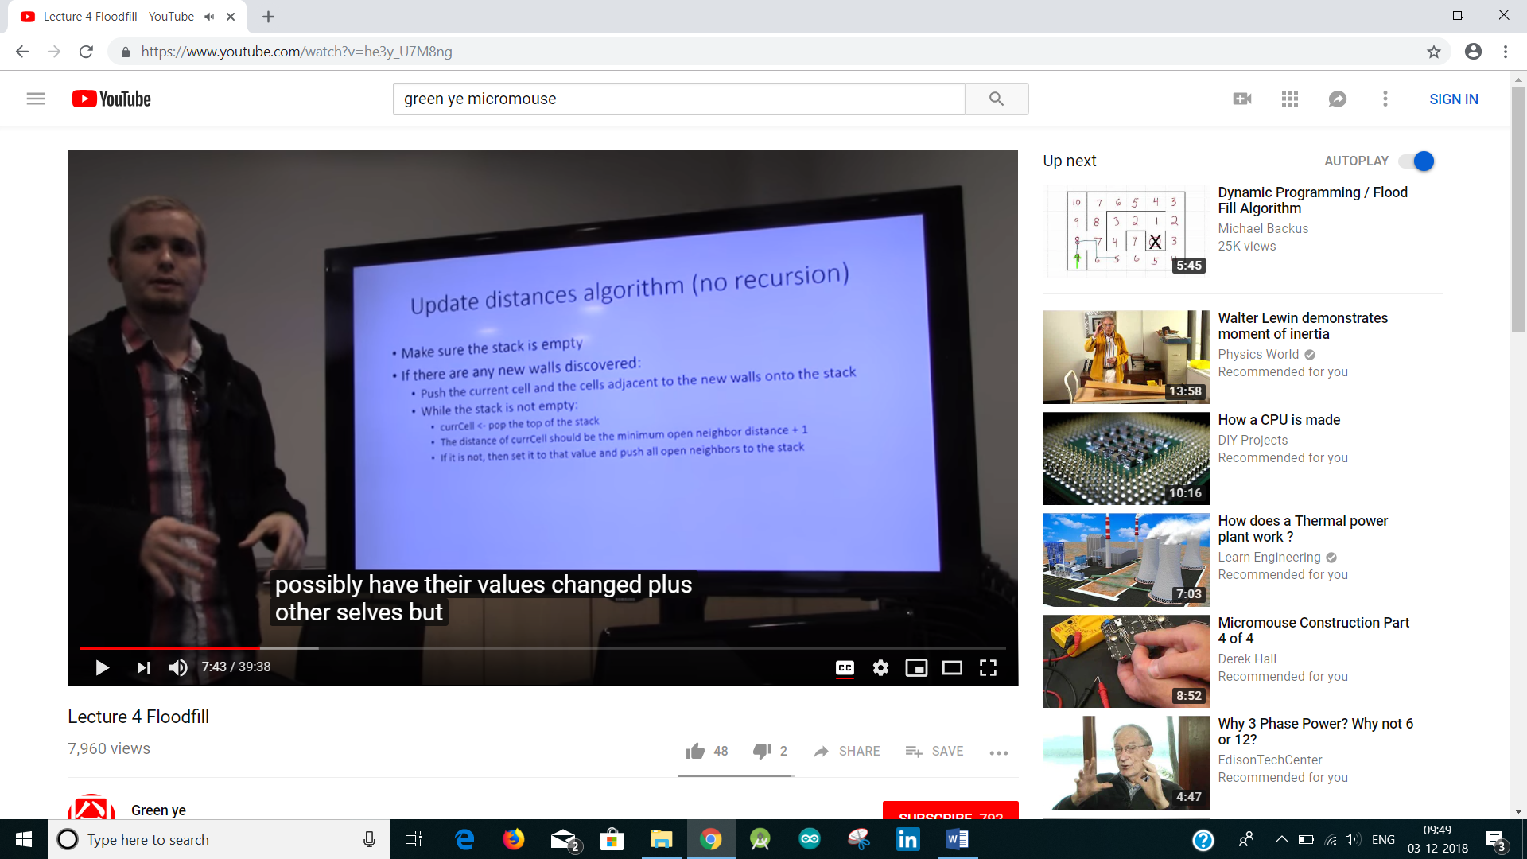

Once you discover a wall you have to update the value of current cell and also the adjacent cells, possibly this part of algorithm will propagate the changes throughout the maze. So its possible to update every single cell of the maze except those at the center.

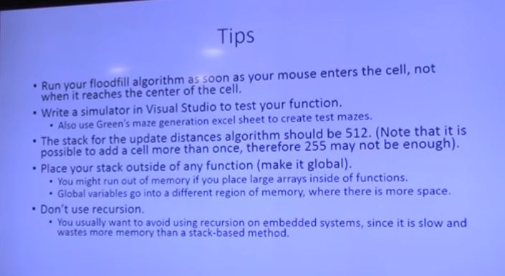

We declare the stack as a global variable. If you call it inside a function, then it stores it in system stack but if declared a global variable it allocates memory space in different regions of memory which has more space.

Q. System stack, the space the program uses, space for global variable, memory, function, region for code Recursive functions takes more memory.???So we use stack method

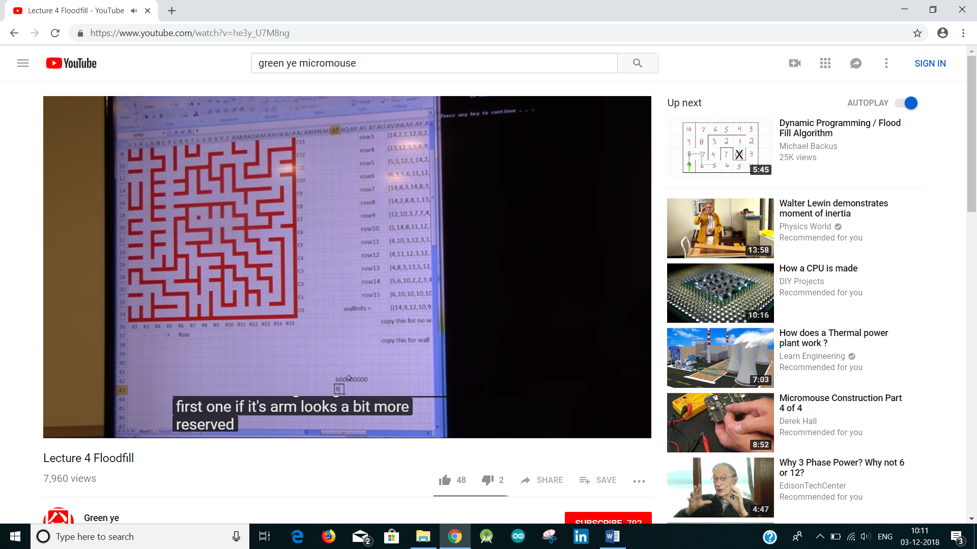

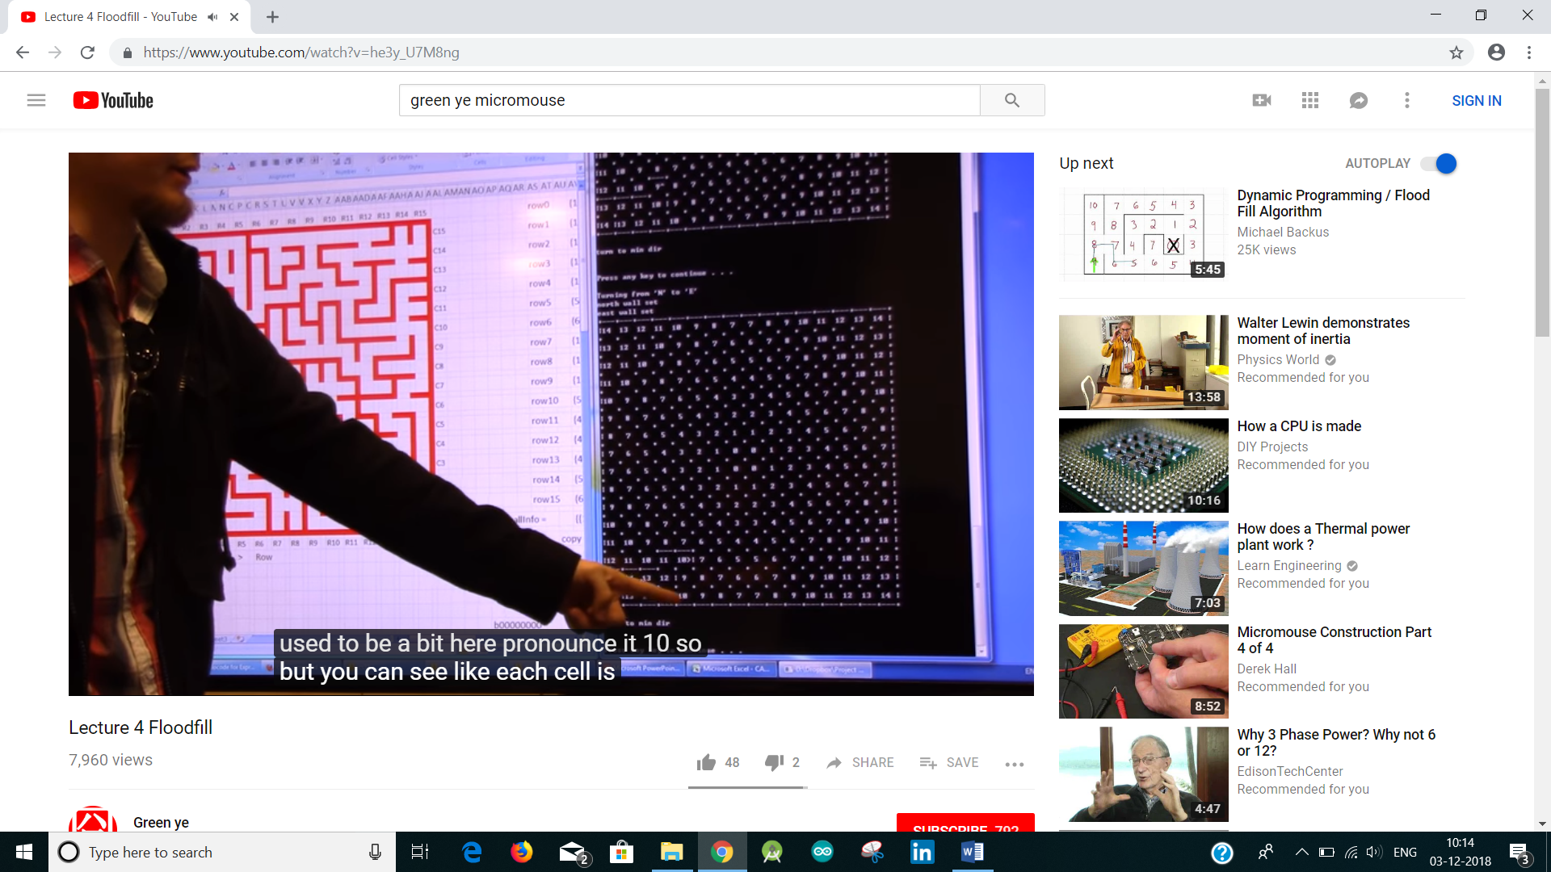

Each time the number in the grid gets updated.

Dynamic Programming: Flood fill

Now we need to make the robot figure out the path to target cell.

